**VISVESVARAYA TECHNOLOGICAL UNIVERSITY**

**Jnana Sangama, Belagavi – 590018**



**ACTIVITY BASED**

**MINI PROJECT REPORT**

**ON**

**Title of the Mini – Project**

**ART GALLERY MANAGEMENT SYSTEM**

**Submitted in partial fulfilment of the requirement for the Database Management Systems Laboratory with Mini Project [21CSL55]**

**Bachelor of Engineering**

**In**

**Department of Information Science and Engineering**

**Submitted By**

|  |  |
| --- | --- |
| USN | Name |
| **1JT21IS048** | **SHREYA H DAVAN** |
| **1JT21IS060** | **VARSHITHA D** |



**DEPARTMENT OF INFORMATION SCIENCE AND ENGINEERING**

**JYOTHY INSTITUTE OF TECHNOLOGY, BENGALURU – 560082**

**JYOTHY INSTITUTE OF TECHNOLOGY**

**Thathaguni, Bengaluru – 560082**

**DEPARTMENT OF INFORMATION SCIENCE AND ENGINEERING**



**CERTIFICATE**

Certified that the mini project work entitled **“Art Gallery Management System”** carried out by **Shreya H Davan [1JT21IS048] and Varshitha D [1JT21IS060]** bonafide students of Jyothy Institute of Technology, in partial fulfilment for the award of **Bachelor of Engineering** in **Information Science and Engineering** department of the **Visvesvaraya Technological University, Belagavi** during the year **2023-2024**. It is certified that all corrections/suggestions indicated for Internal Assessment have been incorporated in the Report deposited in the departmental library. The mini project report has been approved as it satisfies the academic requirements in respect of Mini Project work prescribed for the said Degree.

**Mrs. Anupama V P Dr. Divakar Harekal**

Guide, Asst. Professor Professor and HOD

Dept. of ISE Dept. of ISE

|  |  |
| --- | --- |
| External Viva Examiner | Signature with Date |
|  |  |
|  |  |
|  |  |

**ACKNOWLEDGEMENT**

Firstly, we are very grateful to this esteemed institution **“Jyothy Institute of Technology**” for providing us an opportunity to complete our project.

We express our sincere thanks to our Principal **Dr. Gopalakrishna K** for providing us with adequate facilities to undertake this project

We would like to thank **Dr. Divakar Harekal, Professor and Head** of Information Science and Engineering Department for providing for his valuable support.

We would like to thank our guide **Mrs. Anupama V P, Asst. Prof.** for her keen interest and guidance in preparing this project.

Finally, we would thank all our friends who have helped us directly or indirectly in this project.

**SHREYA H DAVAN[1JT21IS048]**

**VARSHITHA D[1JT21IS060]**

**ABSTRACT**

The Online Art Gallery Management System (OAGMS) is a sophisticated software solution facilitating efficient operations for online art galleries. It offers artists a platform to showcase their work through easy registration and artwork submission processes. Users can explore artworks conveniently categorized by genre, style, and artist, with personalized recommendations for enhanced discovery. Secure payment gateways enable seamless transactions for purchasing artworks. Administrators benefit from comprehensive tools for user and artist management, content moderation, and analytics. The system ensures data security and privacy compliance through robust authentication and encryption mechanisms. The Online Art Gallery Management System (OAGMS) revolutionizes the online art community by providing a seamless and enriching experience for artists, collectors, and enthusiasts. This system provides a platform for both artists and art enthusiasts to interact, showcase, purchase, and manage artworks. The primary goal of OAGMS is to enhance the user experience by offering intuitive interfaces and efficient management tools.

The system incorporates various features such as artist registration, artwork submission, categorization, and online exhibition management. Artists can register on the platform, upload their artworks, and provide descriptions and pricing details. The system facilitates the categorization of artworks based on genres, styles, mediums, and artists, allowing users to easily navigate through the extensive collection.

For art enthusiasts, OAGMS offers a visually appealing interface to explore artworks, search for specific pieces, and learn about artists and their backgrounds. Users can browse through virtual exhibitions, participate in auctions, and securely purchase artworks using integrated payment gateways. Additionally, the system provides personalized recommendations based on user preferences and browsing history, enhancing the discovery process.

**TABLE OF CONTENTS**

|  |  |  |
| --- | --- | --- |
| **Sl No** | **Description** | **Page No.** |
| 1 | INTRODUCTION | 1 - 2 |
| 2 | DESIGN | 3 - 4 |
| 3 | IMPLEMENTATION | 5 - 10 |
| 4 | RESULTS AND SNAPSHOTS | 11 - 14 |
| 5 | CONCLUSION & REFERENCES | 15 - 16 |

***CHAPTER 1***

***INTRODUCTION***

**1.INTRODUCTION**

**1.1 Introduction to DBMS**

A database is simply an organized collection of related data, typically stored on disk, and accessible by many concurrent users, it is a logically coherent collection of data with some inherent meaning, representing some aspect of the real world and which is designed, built and populated with data for a specific purpose.

Databases are managed by a Database Management System (DBMS) which is a collection of programs that enables users to create and maintain a database.

Advantages of DBMS:

1. Redundancy is controlled.

2. Unauthorized access is restricted.

3. Providing multiple user interfaces.

4. Enforcing integrity constraints.

5. Providing backup and recovery.

**1.2 Introduction to SQL**

Structured Query Language (SQL), is a language used to request data from a database which includes database creation, deletion, retrieval of required tables and even manipulation of data held in a relational database management system.

SQL is considered as a Non-Procedural or a High-level language in which the expected result or operation is given without the specific details about how to accomplish the task. So, SQL is a declarative language.

Therefore, SQL is designed at a higher conceptual level of operation than procedural languages as procedural languages include only the information about opening and closing tables, loading and searching indexes, or flushing buffers and writing data to file systems, but the lower level logical and physical operations are not specified in SQL.

**1.3 Art Gallery Management System :**

The specific objectives of the project include:

❖To provide a cutting-edge application designed to seamlessly connect art enthusiasts with their desired masterpieces from the comfort of their own homes.

❖Implementing an online art gallery management system.

❖To buy works of art, sacred texts, models online without need of visiting Exhibition.

* 1. **Scope and importance of work**

It is focused on studying the system of art gallery management and to make sure that the people can purchase art works conveniently. This project keeps records of user inquiries, art products, and art artists. Art Gallery Management System has two modules i.e. admin and user.

**Admin Module**

**1. Dashboard**:  In this section, the admin can briefly view the total number of artists, total answer enquiry, total unanswered enquiry, Total Art Type, total art medium and total art products.

**2. Art Type:**In this section, admin can manage art type (add/delete/update).

**3. Art Medium:**In this section, admin can manage art medium(add/update/delete).

**4. Art Product:**In this section, admin can manage art products(add/update/delete).

**5**.**Enquiry:** In this section, admin can view and maintain the enquiry.

**6. Search Enquiry:**In this section admin, can search for enquiry with the help of the enquiry number.

**6. Page:** In this section, admin can manage the about us and contact us pages..

Admin can also update his profile, change the password and recover the password.

**User Module**

**1. Home:**It is a welcome page for users.

**2. About:**It is an about us page of website.

**3. Art Type:**In this section, users can view art products according to art type and send enquiries for art products.

***CHAPTER-2***

***DESIGN***

**2.1 Theory of ER Diagram**

The Entity–Relationship model (ER model) describes the structure of a database with the help of a diagram, which is known as **Entity Relationship Diagram (ER Diagram)**

An **Entity Relationship Diagram (ERD)** shows the relationships of entity sets stored in a database. An entity in this context is an object, a component of data.

An entity set is a collection of similar entities. These entities can have attributes that define its properties. By defining the entities, their attributes, and showing the relationships between them, an ER diagram illustrates the logical structure of database.

ER diagrams are used to sketch out the design of a database.

**2.2 Entities**

An entity is an 'object' in the real world with an independent existence and an entity type defines a collection (or set) of entities that have the same attributes. Each entity type in the database is described by its name and attributes.

An entity type is represented in ER diagrams as a rectangular box enclosing the entity type name.

**2.3 Relationships**

A relationship among two or more entities represents an association among the entities and whenever an attribute of one entity refers to another entity, there exists a relationship between the two entities.

In a relationship, a foreign key of one table refers to the primary key of the other table and it is represented by a diamond shape in the ER diagram.

**2.4 Attributes**

An attribute represents some property of interest that further describes an entity and the column header of the table shows the attributes. Each attribute in a table has a certain domain which allows it to accept a certain ‘set of values’ only.

The attribute values of each entity will define its characteristics in the table and is represented by oval in the ER diagram

**ENTITY RELATIONSHIP DIAGRAM**

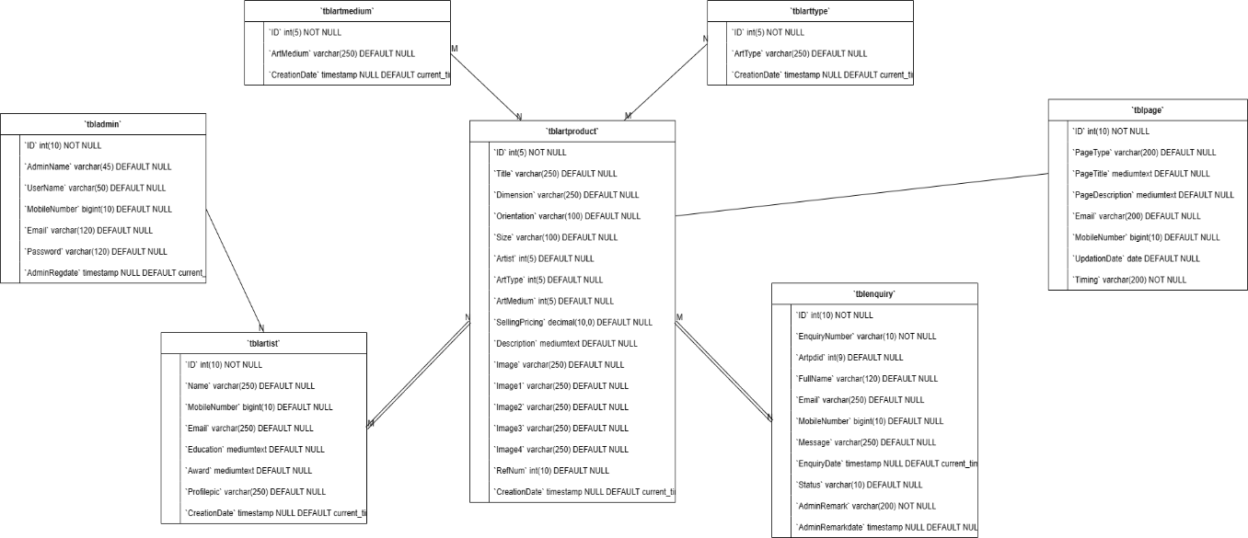

Figure: Entity Relationship Diagram

**LIST OF TABLES**

1. TBLADMIN
2. TBLARTIST
3. TBLARTMEDIUM
4. TBLARTTYPE
5. TBLPRODUCT
6. TBLENQUIRY
7. TBLPAGE

**CHAPTER 3**

**IMPLEMENTATION**

**Create table command & Insertion tables values:**

**ADMIN TABLE**

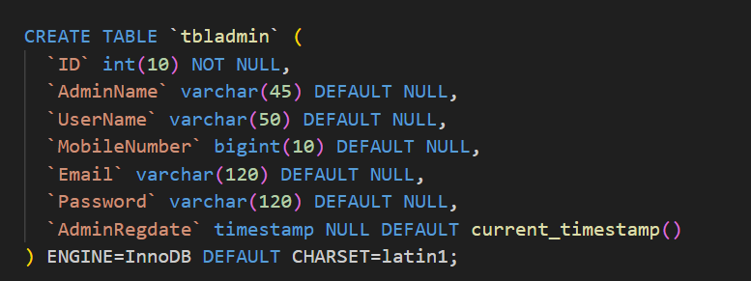

**ARTIST TABLE**

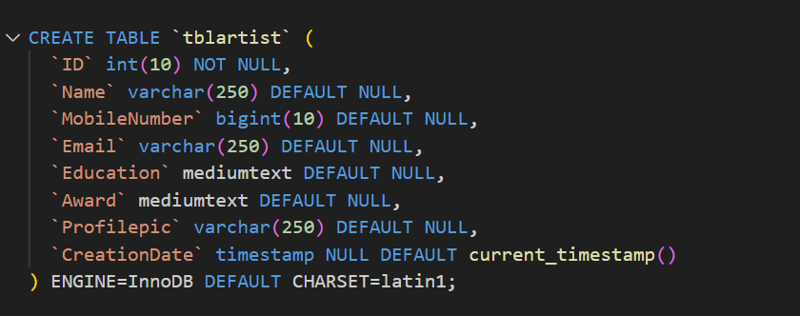

**ART MEDIUM TABLE**

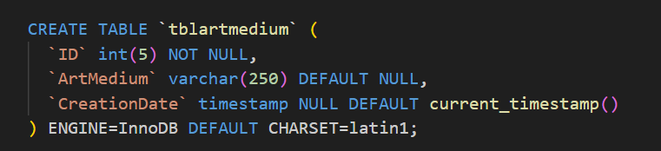

**ART PRODUCT TABLE**

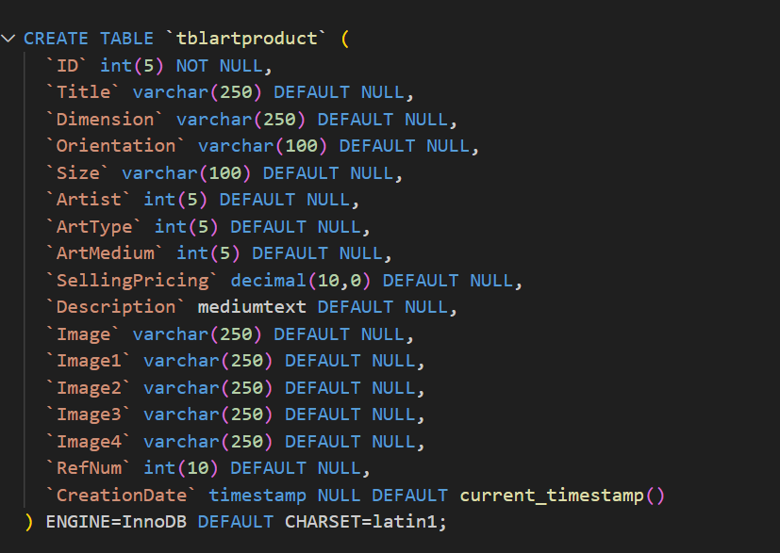

**ART TYPE TABLE**

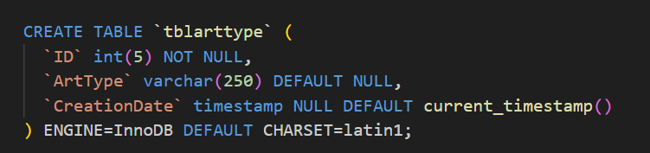

**PAGE TABLE**

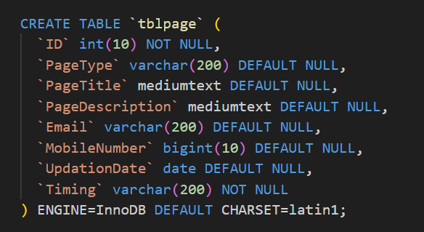

**ENQUIRY TABLE**

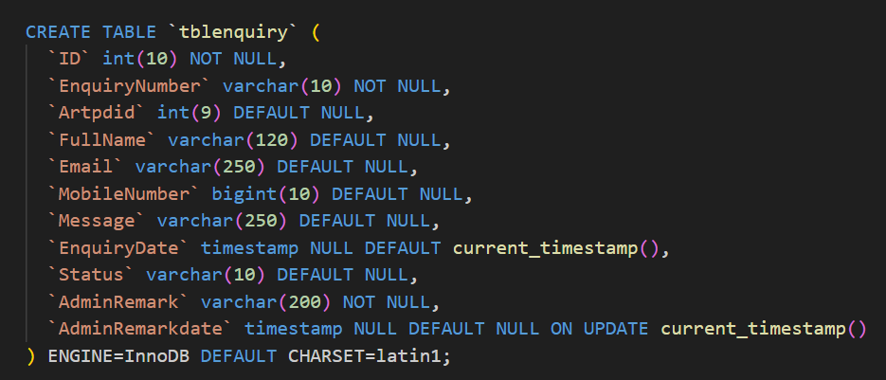

**Snap Shots**

**CREATED TABLES:**

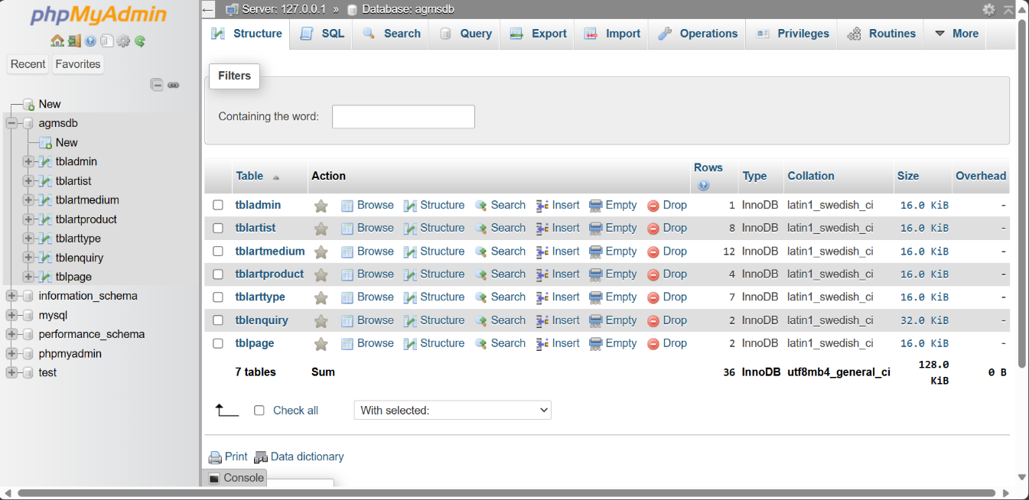

**TOOL** **USED**

**XAMPP:**

**1**.**Apache**:(Application Server)

Apache , often referred to as Server, is an open-source Java Servlet Container developed by the Apache Software Foundation.

**2**.**MySQL** **Server**:

▪It handles large databases much faster than existing solutions.

▪It consists of multi-threaded SQL server that supports different back ends, several different client programs and libraries, administrative tools, and application programming interfaces (APIs)

▪Its connectivity, speed, and security make MySQL Server highly suited for accessing databases on the Internet.

**3.Sublime Text 3.1.1**-

Sublime Text is a sophisticated text editor for code, markup and prose. You’ll love the slick user interface, extraordinary features and amazing performance.

**4.Web browsers**:

Google Chrome,Mozilla Firefox, Opera and Internet Explorer.

**1.Testing**

Testing is evaluation of the software against requirements gathered from users and system specifications. Testing identifies important defects, flaws, or an error in the application code that must be fixed. It also assesses the feature of a system. Testing assesses the quality of the product.

**2.Unit Testing**

Unit testing refers to the testing certain functions and areas of the code. It gives the ability to verify that all the functions work as expected. Eventually, it helps to identify failures in the algorithms as well as logic to help improve the quality of the code that composes a certain function.

**3.Integration Testing**

Integration testing is basically a logical extension of unit testing. In simple words, two tested units are combined into a component and the interface between them is tested. It identifies problems that occur when different units are combined. The different modules of this project have undergone integration testing while being merged.

**4.System Testing**

System testing tests the behavior of whole system as defined by the scope of the development project.

It might include tests based on risks as well as requirement specifications, business process, use cases or other high-level descriptions of system behavior, interactions with the operating systems and system resources. It is most often the final test performed to verify that the system meets the specification and its objectives. System testing has been performed at the completion of each feature and is still taking place to make improvements on the existing system.

**1.System Analysis**

System Analysis is a detailed study of the various operations performed by a system and their relationships within and outside of the system. Here the key question is- why all problems exist in the present system? What must be done to solve the problem? Analysis begins when a user or manager begins a study of the program using existing system. During analysis, data collected on the various files, decision points and transactions handled by the present system. The commonly used tools in the system are Data Flow Diagram etc. Training, experience and common sense are required for collection of relevant information needed to develop the system. The success of the system depends largely on how clearly the problem is defined, thoroughly investigated and properly carried out through the choice of solution. A good analysis model should provide not only the mechanisms of problem understanding but also the frame work of the solution. Thus, it should be studied thoroughly by collecting data about the system. Then the proposed system should be analyzed thoroughly in accordance with the needs. System analysis can be categorized into four parts.

●System planning and initial investigation

●Information Gathering

●Applying analysis tools for structured analysis

●Feasibility study

●Cost/ Benefit analysis.

In our existing system the recording of user’s information is done manually, So taking more time for searching the information of the users. Another major disadvantage is that preparing the list of members that viewed any user’s information takes more time. So, after conducting the feasibility study I decided to make the agro culture System to be computerized.

**2 Problem Analysis**

It is related with the accessing the detailed information of a user and a candidate. So, I have initiated this project with simple requirements regarding the user and candidate information. Some of the problems for designing and developing this project are discussed below:

**2.1Design and Development Problem**

●Problem in running XAMPP.

●To debug the error during the development.

●To show a relationship between entity.

●Minor error with database table.

**ALTER COMMAND**

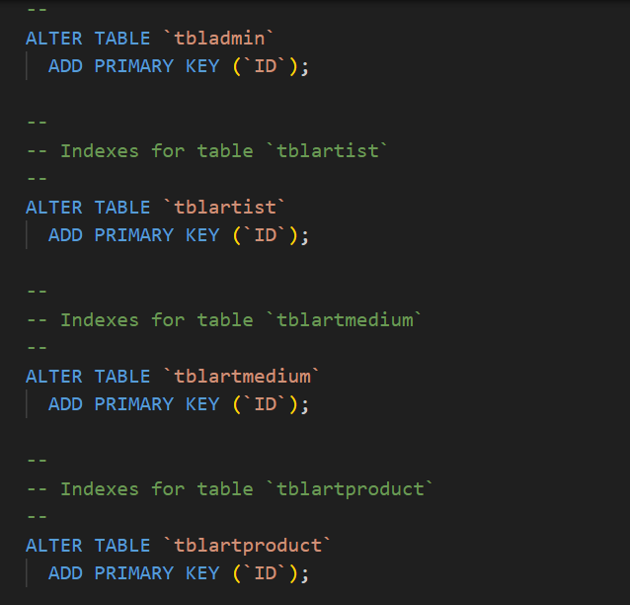







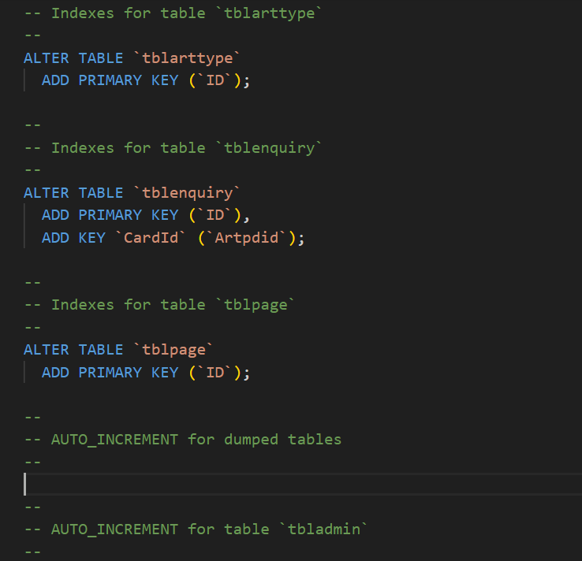





**AUTO-INCREMENT**

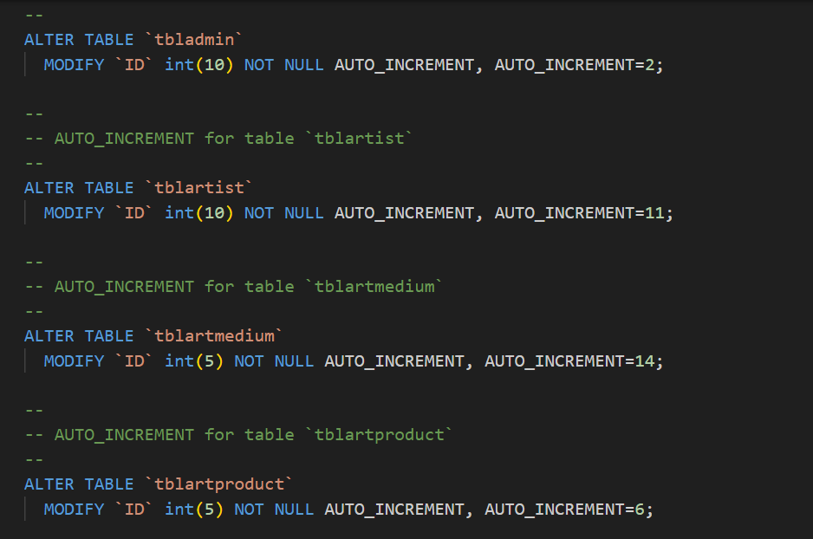







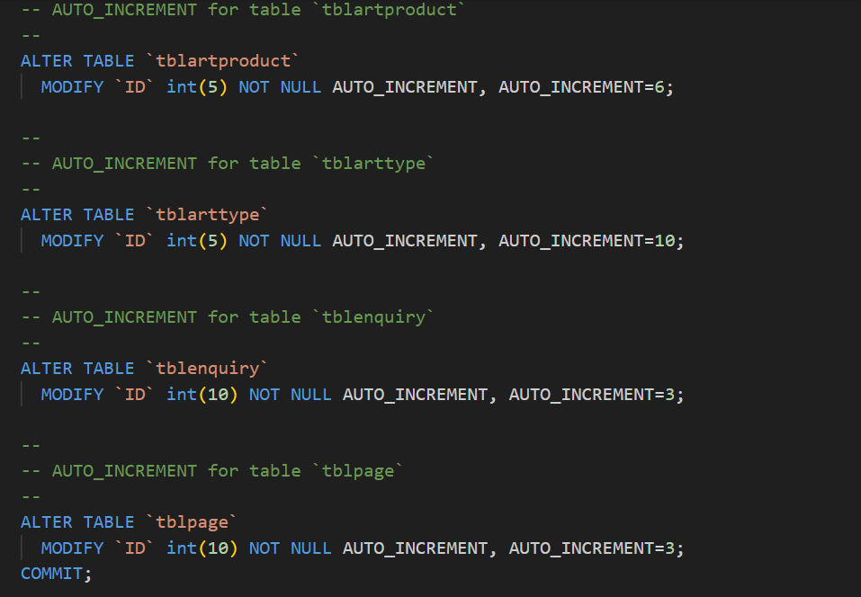





***CHAPTER 4***

***RESULTS AND SNAPSHOTS***

**Home Page**

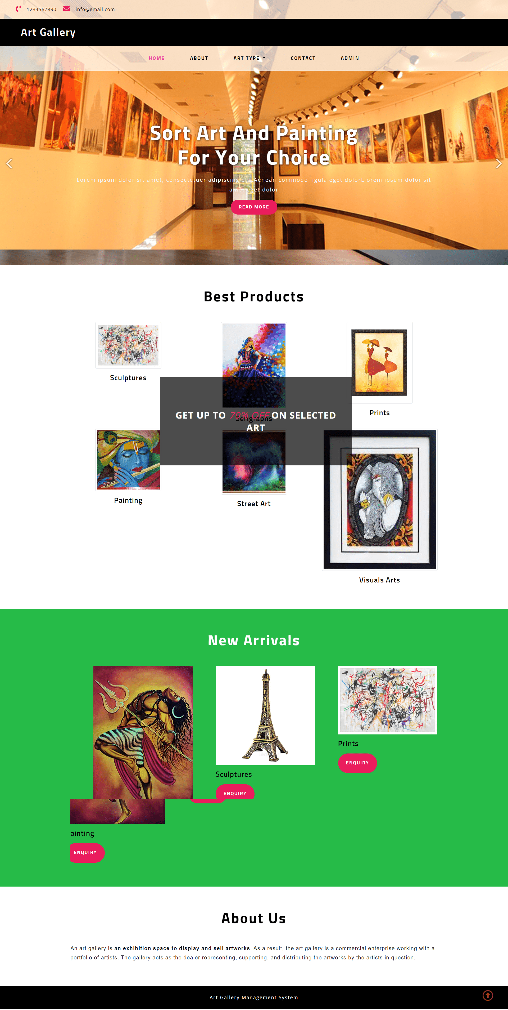

**Art Details Page**

AGMS Art Details


**Admin Dashboard**.

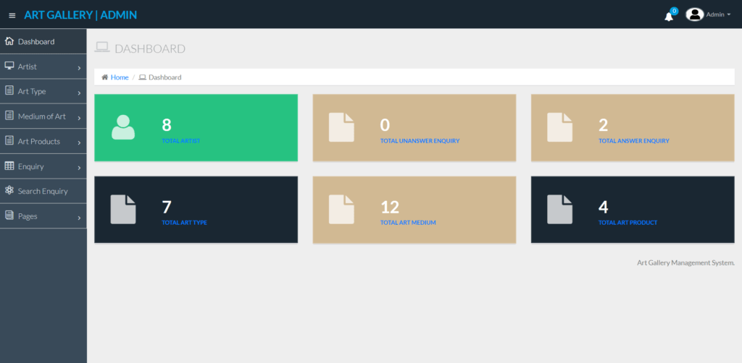

**Add Art**

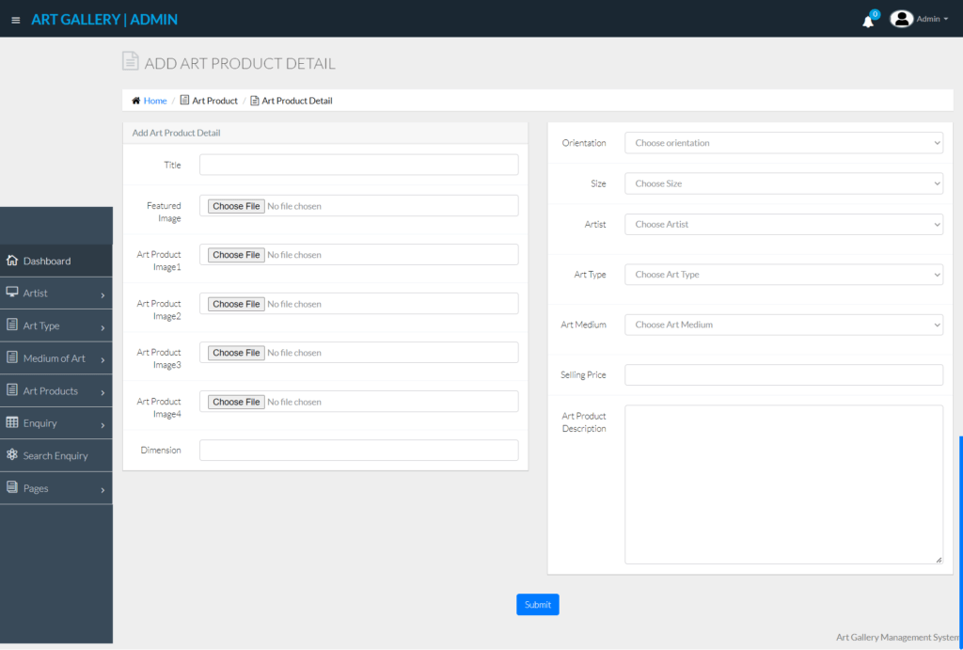

***CHAPTER 5***

***CONCLUSION & REFERENCES***

**CONCLUSION**

Concluding a mini-project on an online art gallery database management system (DBMS) involves summarizing the key features, challenges faced. In conclusion, the Online Art Gallery Management System represents a paradigm shift in the way art is bought and sold, offering unparalleled convenience, accessibility, and choice to enthusiasts worldwide. Whether you’re a seasoned collector or a novice admirer, our platform provides the perfect avenue to explore, discover, and acquire exquisite artworks that resonate with your unique tastes and preferences. It provides a platform for artists to showcase and sell their work, reach a wider audience, and manage their inventory and sales. For art enthusiasts, it offers a convenient way to explore and purchase art from a diverse range of artists and styles.

Key features of such this system may include user-friendly interfaces for browsing and purchasing art, secure payment processing, artist profiles and portfolios, virtual exhibitions, and tools for managing inventory, orders, and shipping. Overall, an online art gallery management system can enhance the art-buying experience for customers and provide valuable support for artists in promoting and selling their work.

REFERENCES

1. MySQL Database <https://www.mysql.com/downloads/>
2. PHP

<http://php.net/>